CURRICULUM VITAE

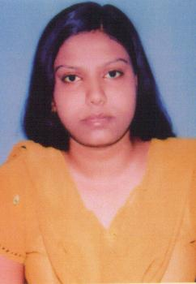

NEHA SINHA
K-37/16
River View Telco Colony,
Jamshedpur -831004
East Singhbhum

E-mail id: neha.sinha665@gmail.com
Mobile no: 7209651060

CAREER OBJECTIVE
My career objective is to be a part of a professionally managed growth oriented organization which will help me enhance my inner qualities.

EDUCATIONAL QUALIFICATIONS
Pursuing MBA with Major (HRM) and Minor (FINANCE) specialization from Netaji Subhas Institute of Business Management, Jamshedpur.
Degree/ Examination | Institution | University/Board | Year of Passing | Percentage %
MBA | NSIBM  Jamshedpur | Kolhan University | Pursuing
BBA | B.I.T Mesra,  Ranchi | Deemed University | 2010 | 73.1
12th | Little Flower School, Jamshedpur | Delhi Board | 2007 | 64
10th | Little Flower School, Jamshedpur | Delhi Board | 2005 | 61

PROFESSIONAL HIGHLIGHTS

- Creative and innovative
- Good communication skill
- Active listener – Willing to learn and listen
- Team Lead abilities
- Formal presentation skills

HOBBIES

- I am interested in listening to music and playing badminton

SEMINARS
- World Vision 2030 by SANTOSH SHARMA(Manager Air India)
- What The Corporate World Expect from Today’s Manager By DEKKY MODI(Director TSRDS & Trainer TATA STEEL MANAGEMENT TRAINING CENTRE)
- Emerging Prospects in Public Administration and Focus on E-governance by Dr AJAY KUMAR(Ex-IPS,MP-East Singhbhum)

PERSONAL DETAILS

Name : Neha Sinha
Father : Mr. B.K.Sinha
Sex : Female
Marital Status : Single
Nationality : Indian
Languages : English, Hindi
Date of Birth : 2nd August 1989

CORRESPONDENCE ADDRESS
D/O B.K.SINHA
K-37/16
River View Telco Colony,
Jamshedpur -831004
East Singhbhum

REFERENCE
1 Prof. A.K.Ghosh (DIRECTOR – Academics), NSIBM, JAMSHEDPUR
VOICE:-+919304802182

DECLARATION

I hereby declare that the above mentioned information is correct up to my knowledge and I bear the responsibility for the correctness of the above mentioned particulars.

Place: Jamshedpur Neha Sinha

